Insertion sort:

Source: [Insertion Sort - Data Structure and Algorithm Tutorials - GeeksforGeeks](https://www.geeksforgeeks.org/insertion-sort/)

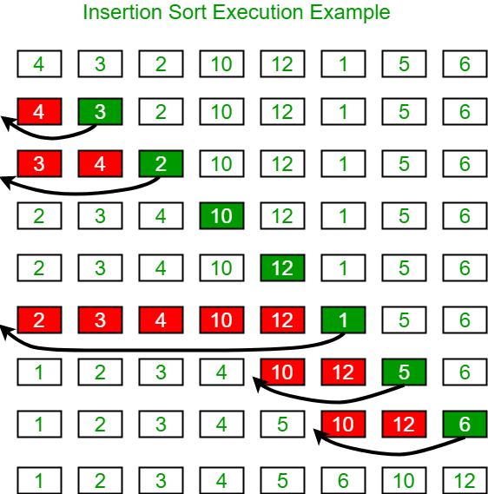

1. 4 checks if there is anything behind it to compare to and there is not so it moves to 3
2. 3 checks 4 behind it and 4 is greater than 3 so they switch
3. 2 checks behind and it sees 4 so 4 and 2 switch and 2 checks again if there is anything behind it and 3 is so they switch again
4. Repeat these steps, checking behind it and switching if the number behind it is greater than the number we are currently on.